**Sheet No. (2) Subject: Artificial intelligent**

**Question 1:**

Consider breadth-first search and depth –first search. The costs are ignored in breadth-first search, so it is searching in the space without weights**. Assume A is start node and G is Goal node**

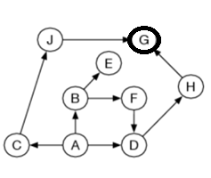

**Question 2:**

The graph shows the step-costs for different paths going from the start (S) to the goal (G).

Use uniform cost search to find the optimal path to the goal**.**

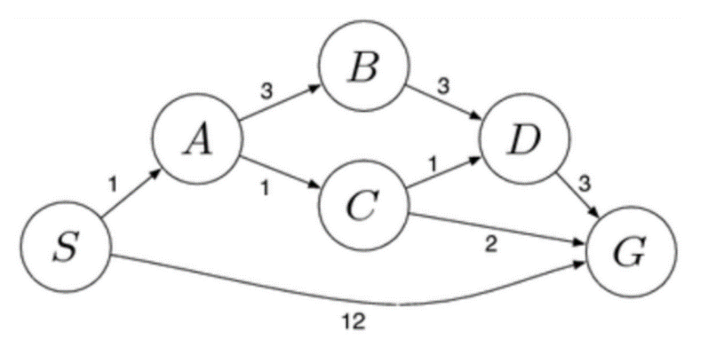

**Question 3:**

The graph shows the step-costs for different paths going from the start (S) to the goal (G). Use uniform cost search to find the optimal path to the goal**.**

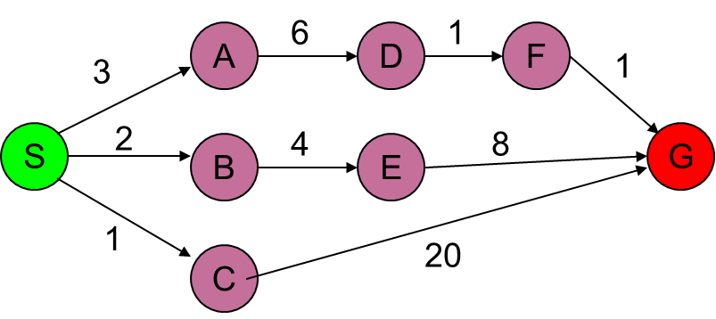

**Question 4:**

Consider breadth-first search and depth –first search. The costs are ignored in breadth-first search, so it is searching in the space without weights**. Assume A is start node and E is Goal Node**

